PYTHON ACTIVITY BASED LEARNING
PROBLEM 4
Problem Statement:
Employee Payroll and Deduction Analysis: Calculate gross salary from basic pay, allowances, overtime, and incentives; apply progressive deductions and generate a formatted salary statement
. Objective
To develop a Python program that calculates an employee's gross salary using basic pay, allowances, overtime, and incentives. The program applies progressive deductions, calculates net salary, and generates a formatted salary statement.
2. Program (Python)
# Employee Payroll and Deduction Analysisname = input("Enter employee name: ")basic = float(input("Enter basic pay: "))allowances = float(input("Enter allowances: "))overtime = float(input("Enter overtime pay: "))incentives = float(input("Enter incentives: "))if basic < 0 or allowances < 0 or overtime < 0 or incentives < 0: print("Invalid input: Salary values cannot be negative.")else: gross = basic + allowances + overtime + incentives # Progressive deductions if gross <= 20000: deduction = gross * 0.05 elif gross <= 50000: deduction = 20000 * 0.05 + (gross - 20000) * 0.10 else: deduction = (20000 * 0.05 + 30000 * 0.10 + (gross - 50000) * 0.15) net_salary = gross - deduction print("\n========== SALARY STATEMENT ==========") print("Employee Name :", name) print("Basic Pay : Rs.", round(basic, 2)) print("Allowances : Rs.", round(allowances, 2)) print("Overtime Pay : Rs.", round(overtime, 2)) print("Incentives : Rs.", round(incentives, 2)) print("--------------------------------------") print("Gross Salary : Rs.", round(gross, 2)) print("Deductions : Rs.", round(deduction, 2)) print("Net Salary : Rs.", round(net_salary, 2)) print("======================================")
3. Algorithm
- Start.
- Input employee name, basic pay, allowances, overtime pay, and incentives.
- Validate that all salary values are non-negative.
- Calculate gross salary by adding basic pay, allowances, overtime, and incentives.
- Calculate progressive deductions:
  - Up to ₹20,000: 5%.
  - ₹20,001 to ₹50,000: 5% on the first ₹20,000 and 10% on the next ₹30,000.
  - Above ₹50,000: apply the previous deductions and 15% on the amount exceeding ₹50,000.
- Calculate net salary by subtracting deductions from gross salary.
- Display the formatted salary statement.
- Stop.
Flowchart
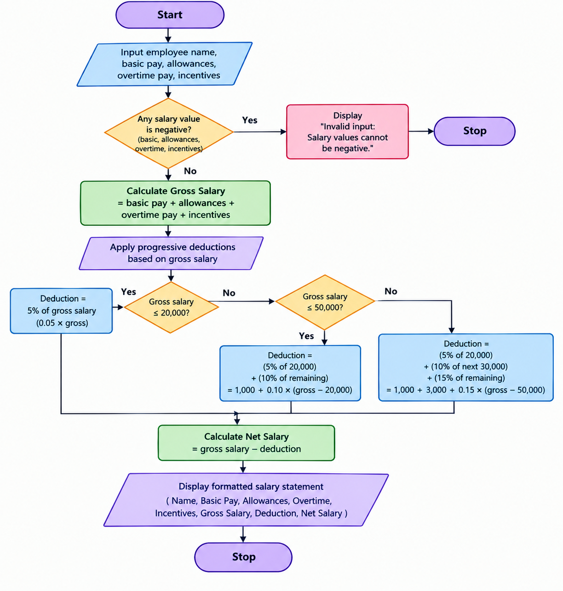
4. Pseudocode
BEGIN
INPUT employee_name
INPUT basic_pay, allowances, overtime, incentives

IF any salary value < 0 THEN
DISPLAY "Invalid input"
ELSE
gross = basic_pay + allowances
+ overtime + incentives

IF gross <= 20000 THEN
deduction = gross * 5 / 100
ELSE IF gross <= 50000 THEN
deduction = 20000 * 5 / 100
+ (gross - 20000) * 10 / 100
ELSE
deduction = 20000 * 5 / 100
+ 30000 * 10 / 100
+ (gross - 50000) * 15 / 100
END IF

net_salary = gross - deduction

DISPLAY employee_name
DISPLAY gross, deduction, net_salary
END IF
END
5. Sample Output
Enter employee name: Ravi
Enter basic pay: 30000
Enter allowances: 5000
Enter overtime pay: 2000
Enter incentives: 3000

========== SALARY STATEMENT ==========
Employee Name : Ravi
Basic Pay : Rs. 30000.0
Allowances : Rs. 5000.0
Overtime Pay : Rs. 2000.0
Incentives : Rs. 3000.0
--------------------------------------
Gross Salary : Rs. 40000.0
Deductions : Rs. 3000.0
Net Salary : Rs. 37000.0
======================================
Result
The program calculates gross salary, applies progressive deductions, and displays the employee's net salary in a formatted salary statement.

